1. Update text - Find & Book the Best Venue for Your Special Event
2. Update filter - 1) Event Type (Wedding Ceremony, Wedding Reception, Engagement Ceremony, Birthday Party, Birthday Party for Kids, Corporate Party, Corporate Events)

2) City 3) Location

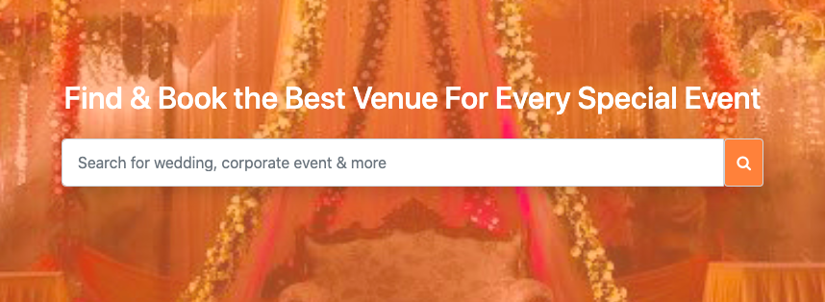

1. Replace Marriage Anniversary from Wedding Anniversary.
2. Tabs – There should be gap between **Contact Us** and **List Your Business**. Till **Contact Us**, it should be left and **List Your Business would be in right.**
3. **We need right our best thing in Home above search filter.**